1. Design the transition logic using sequencer-decoder method for the following state diagram, use logic states for the condition signals-   
     
     
      
     
      
    Am = 0 Am = 1  
     
     
    Pq = 1   
     
    Pq = 0

1. 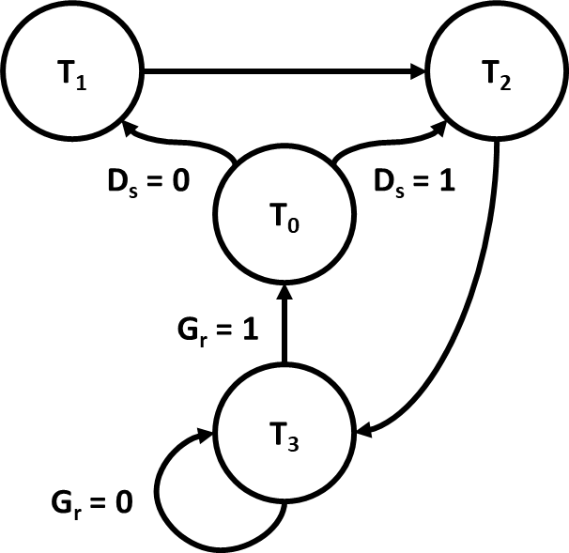Design the transition logic using sequencer-decoder method for the following state diagram, use logicstates for the condition signals-

1. Design the transition logic using sequencer-decoder method for the following state diagram, use logic states for the condition signals-

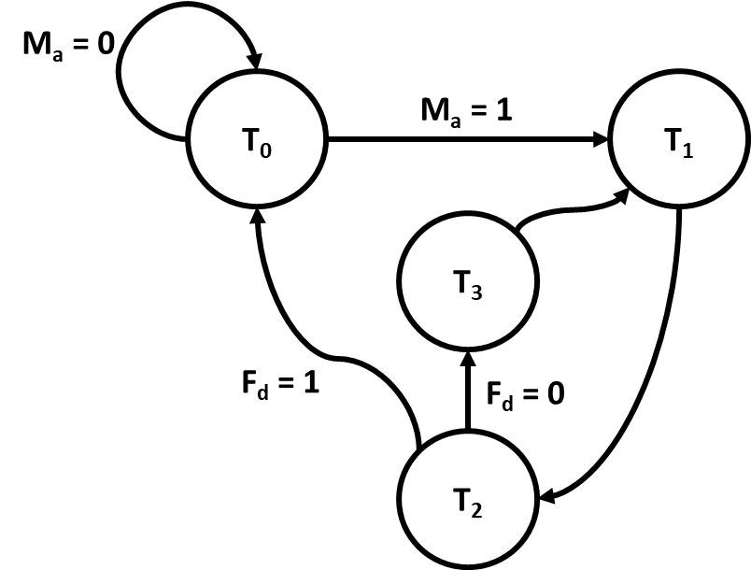

1. Design a 2-bit ALU with the following specification -

|  |  |
| --- | --- |
| **S0** | **Operation** |
| 0 | A – B – 1 |
| 1 | A or B |

1. Design a 2-bit Accumulator with the following specification -

|  |  |
| --- | --- |
| **Control Signal** | **Operation** |
| p1 | A’ – 1 |

1. Design a 2-bit ALU with the following specification -

|  |  |
| --- | --- |
| **S0** | **Operation** |
| 0 | A – 1 |
| 1 | A xor B |

1. Design a 2-bit Accumulator with the following specification -

|  |  |
| --- | --- |
| **Control Signal** | **Operation** |
| p1 | A nand B |

1. Design a 2-bit ALU with the following specification -

|  |  |
| --- | --- |
| **S0** | **Operation** |
| 0 | A – B |
| 1 | A’ |

1. Design a 2-bit Accumulator with the following specification -

|  |  |
| --- | --- |
| **Control Signal** | **Operation** |
| p1 | A xnor B |

1. Design a 2-bit ALU with the following specification -

|  |  |
| --- | --- |
| **S0** | **Operation** |
| 0 | B – 1 |
| 1 | A or B |

1. Design a 2-bit Accumulator with the following specification -

|  |  |
| --- | --- |
| **Control Signal** | **Operation** |
| p1 | A xor B |

1. Design a 2-bit ALU with the following specification -

|  |  |
| --- | --- |
| **S0** | **Operation** |
| 0 | B – A |
| 1 | B’ |

1. Design a 2-bit Accumulator with the following specification -

|  |  |
| --- | --- |
| **Control Signal** | **Operation** |
| p1 | A + 1 |

1. Design a 2-bit ALU with the following specification -

|  |  |
| --- | --- |
| **S0** | **Operation** |
| 0 | B |
| 1 | B’ |

1. Design a 2-bit Accumulator with the following specification -

|  |  |
| --- | --- |
| **Control Signal** | **Operation** |
| p1 | A – B – 1 |

1. Design a 2-bit ALU with the following specification -

|  |  |
| --- | --- |
| **S0** | **Operation** |
| 0 | B – A |
| 1 | A’ |

1. Design a 2-bit Accumulator with the following specification -

|  |  |
| --- | --- |
| **Control Signal** | **Operation** |
| p1 | B – A – 1 |